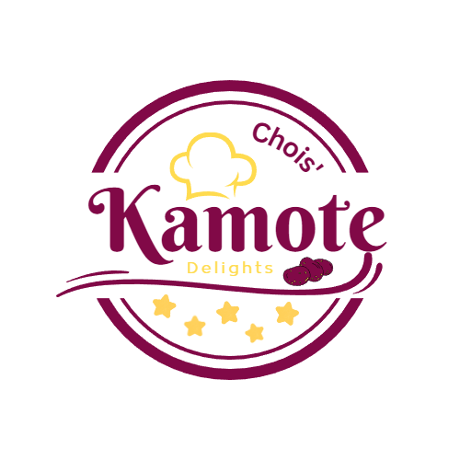***Chois’ Kamote Delights***

Business Plan

Presented To

**Mrs. Jazzie Mae Acorin**

Date Prepared

**05/26/2023**

Choi Foods Corporation

[choifoodscorp@gmail.com](mailto:choifoodscorp@gmail.com)

+639203773846

Potungan National Highschool

Potungan, Dapitan City, Zamboanga del Norte

1

**Table of Contents**

Title Page……………………………………………………………………………………………….1

Table of Contents……………………………………………………………………….………………

I. Introduction………………………………………………………………..………………...

* The Business Concept and the Business Model............................................................
* The Business Goals: Vision, Mission, Objectives, and Performance Targets……………………………………………..…………………………..............
* The Business Offering and Justification……………………………………………..…..........................................

II. Executive Summary……………………………………………….……………………....

III. The Business Proponents: Organizers with their Capabilities and Contributions…………

IV. The Target Customers and the Main Value Proposition to the Customer…………………..

V. The Market, Market Justification based on the Industry Dynamics and the Macro Environmental Factors Affecting the Opportunities and Threats in the Market, the Size, Potential and Realistic Share of the Market……………………………………………………………………………..

VI. The Product and Service Offerings…………………………………………………………..

VII. The Enterprise Strategy and Enterprise Delivery System: Business Competitiveness……

VIII. The Financial Forecasts and Expected Returns, Risks, and Contingencies……………….

IX. Environmental and Regulatory Compliance……………………………………………..

X. The Capital Structure and Financial Offering: Returns and Benefits to Investors,

Financers, and Business Partners……………………………………………………………….

Appendix………………………………………………………………………………….

2

**I. Introduction**

**The Business Concept and the Business Model**

Chois’ Kamote Delights is a food business that offers a range of delectable and unique products centered around Kamote (Sweet Potato). Our concept combines the deliciousness and versatility of Kamote in the form of Kamote Fries, Kamote Doughnuts, and Kamote Ice Candies. We aim to provide customers with a variety of innovative and wholesome Kamote-based treats that cater to different taste preferences.

Chois’ Kamote Delights generates revenue by selling Kamote Fries, Kamote Doughnuts, and Kamote Ice Candies. The key factors for revenue include building brand awareness through effective marketing, offering a diverse menu to cater to different tastes, ensuring consistent product quality and presentation, and providing a pleasant customer experience in person or online.

The enterprise's costs include raw materials, packaging, marketing expenses, and overhead costs. To ensure profits, cost management strategies involve sourcing ingredients from reliable suppliers at competitive prices, minimizing waste through efficient inventory management, controlling ingredient costs through portion control and standardized recipes, maximizing ROI through effective marketing strategies, and adjusting pricing to meet market demand and maintain profitability.

The major investments for Chois’ Kamote Delights include kitchen equipment for efficient production, branding elements to create a cohesive identity, attractive packaging and labeling, and marketing and advertising efforts. These investments provide a competitive edge by enabling efficient operations, enhancing brand recognition, improving the customer experience, and differentiating the business from competitors.

The enterprise can be financed through personal funds, or investments from stakeholders. To fund its growth, the enterprise can reinvest profits to expand the business and explore reselling opportunities in markets. Effective financial management, positive cash flow, and a strong business plan are crucial for attracting financing and fueling expansion.

3

**The Business Goals: Vision, Mission, Objectives, and Performance Targets**

**Our Vision**

To become the leading provider of innovative and delightful Kamote-based treats, serving customers with our unique flavors and commitment to quality and creativity.

**Our Mission**

Our mission is to offer a diverse range of Kamote Delights that cater to various taste preferences, providing customers with delicious options made from high-quality ingredients. We strive to create an exceptional experience and promote the versatility and health benefits of Kamote.

4

**Objectives**

* Product Excellence
* Develop and refine recipes for Kamote Fries, Kamote Doughnuts, and Kamote Ice Candies to ensure consistent quality, taste, and presentation.
* Conduct regular taste tests and customer surveys to gather feedback and improve product offerings.
* Introduce seasonal and limited-time flavors to provide variety and keep customers engaged.
* Customer Satisfaction
* Deliver exceptional customer service, creating a welcoming and friendly environment for all customers.
* Continuously monitor customer feedback and reviews to address any concerns or areas for improvement promptly.
* Brand Awareness and Market Expansion
* Increase brand awareness through effective marketing and advertising strategies, including social media campaigns, collaborations, and targeted promotions.
* Establish partnerships with local retailers and explore opportunities for product distribution in grocery stores and online platforms.
* Operational Efficiency
* Streamline processes and optimize resource allocation to maximize productivity and minimize costs.
* Implement an inventory management system to track ingredient usage, reduce waste, and ensure optimal stock levels.

5

**Key Result Areas (KRAs) and Performance Indicators**

* Product Quality
  + KRA: Ensure consistent product quality and taste across all Kamote Delights.
  + Performance Indicators: Customer feedback ratings, product quality evaluations.
* Customer Experience
  + KRA: Provide an exceptional experience and maintain high customer satisfaction.
  + Performance Indicators: Customer satisfaction surveys, online reviews and ratings.
* Brand Awareness
  + KRA: Increase brand visibility and recognition in the target market.
  + Performance Indicators: Social media engagement, brand recognition surveys.
* Business Expansion
  + KRA: Expand the business by opening resellers and exploring distribution partnerships.
  + Performance Indicators: Number of new resellers, revenue growth from new distribution channels.

These objectives and key result areas will be measured regularly, monitored closely, and adjusted as needed to ensure progress towards the overall business goals.

6

**The Business Offering and Justification**

Our business, Chois’ Kamote Delights, offers a unique and diverse range of Kamote-based treats that cater to different taste preferences. Our offerings include:

* Kamote Fries Delights

Crispy and flavorful fries made from fresh Kamote, seasoned with a variety of spices and served with a selection of delicious dipping sauces. Our Kamote Fries are a healthier alternative to traditional French fries, providing a satisfying snack or side dish option.

* Kamote Doughnut Delights

Soft and fluffy doughnuts made with the goodness of Kamote. These doughnuts come in various flavors and toppings, ranging from classic sugar to unique combinations like caramel and flavored milk. Our Kamote Doughnuts are a delightful treat for breakfast or anytime indulgence.

* Kamote Ice Candy Delights

Refreshing and frozen treats made from pureed Kamote and natural fruit flavors. Our Kamote Ice Candies are the perfect choice for beating the heat, offering a healthy and guilt-free alternative to traditional ice cream. It's a favorite among both kids and adults.

7

**Justification**

* Unique and Innovative

Our business offering stands out in the market due to its innovative use of Kamote, a versatile and nutritious root vegetable. By incorporating Kamote into popular treats like fries, doughnuts, and ice candies, we provide customers with a unique and exciting culinary experience.

* Healthier Alternative

Kamote is known for its health benefits, being rich in vitamins, fiber, and antioxidants. By using Kamote as a base ingredient, we offer customers a healthier alternative to traditional snacks and desserts, catering to the increasing demand for nutritious and wholesome food options.

* Diverse Menu

Our menu caters to a wide range of taste preferences, allowing customers to choose from different flavors and toppings. Whether someone prefers savory or sweet, our Kamote Delights menu offers something for everyone, ensuring customer satisfaction and repeat sales.

* Quality and Freshness

We prioritize the quality and freshness of our ingredients. We source fresh Kamote from reliable suppliers and carefully select high-quality spices, toppings, and other ingredients. Our commitment to quality ensures that customers enjoy the best flavors and textures in every bite.

* Memorable Experience

We strive to create a welcoming and enjoyable experience for our customers. From the visually appealing presentation of our products to friendly customer service, we aim to leave a lasting impression on our customers, encouraging them to return and recommend us to others.

By offering innovative Kamote-based treats that are both delicious and nutritious, Chois’ Kamote Delights sets itself apart in the market, capturing the attention of health-conscious individuals, food enthusiasts, and those seeking unique culinary experiences. With a diverse menu, commitment to quality, and memorable experience, we aim to establish Chois’ Kamote Delights as the go-to destination for Kamote-inspired delights.

8

**II. Executive Summary**

Chois’ Kamote Delights is a food business that specializes in offering a range of unique and delectable Kamote-based products. Our concept revolves around Kamote Fries, Kamote Doughnuts, and Kamote Ice Candies, providing customers with innovative and wholesome treats that cater to different taste preferences.

Our revenue is generated through the sale of these Kamote Delights. Key factors that drive revenue include effective marketing to build brand awareness, offering a diverse menu to cater to varied tastes, ensuring consistent product quality, and creating a pleasant customer experience both in-person and online.

To ensure profitability, we manage costs by sourcing ingredients from reliable suppliers at competitive prices, minimizing waste through efficient inventory management, controlling ingredient costs through portion control and standardized recipes, maximizing ROI through effective marketing strategies, and adjusting pricing according to market demand.

Our major investments include acquiring kitchen equipment for efficient production, branding elements for a cohesive identity, attractive packaging and labeling, and marketing and advertising efforts. These investments provide us with a competitive edge by enabling efficient operations, enhancing brand recognition, improving the customer experience, and differentiating us from competitors.

Financing for our enterprise can come from personal funds or investments from stakeholders. We plan to fund our growth by reinvesting profits into expanding the business and exploring reselling opportunities in new markets. Effective financial management, positive cash flow, and a strong business plan will be essential in attracting financing and fueling our expansion.

9

Our business goals revolve around our vision to become the leading provider of innovative and delightful Kamote-based treats. Our mission is to offer a diverse range of Kamote Delights made from high-quality ingredients, creating an exceptional experience and promoting the versatility and health benefits of Kamote.

To achieve our objectives, we will focus on product excellence, customer satisfaction, brand awareness and market expansion, and operational efficiency. Key result areas and performance indicators will help us measure progress and ensure that we meet our goals.

By offering unique and diverse Kamote-based treats, we provide customers with a delightful and healthier alternative to traditional snacks and desserts. Our commitment to quality, freshness, and a memorable experience sets us apart in the market, capturing the attention of health-conscious individuals, food enthusiasts, and those seeking unique culinary experiences.

With a menu that caters to varied tastes, a focus on quality and innovation, and a commitment to customer satisfaction, Chois’ Kamote Delights aims to establish itself as the go-to destination for Kamote-inspired delights.

10

**III. The Business Proponents: Organizers with their Capabilities and Contributions**

Chois’ Kamote Delights is backed by a team of highly capable and dedicated organizers who bring diverse skills and expertise to the business. Their collective contributions and capabilities ensure the success and smooth operation of the enterprise.

**John Paul Dagpin, Culinary Expert**

John Paul is a food lover with a passion for innovative culinary creations. With years of expertise in home-based cooking, John brings his exceptional skills in recipe development, flavor profiling, and menu planning to Chois’ Kamote Delights. His deep understanding of food trends and customer preferences enables him to craft unique and delicious Kamote-based treats that set the business apart.

**Remdel Jim Acal, Operations and Logistics Manager**

Remdel Jim is an operations and logistics manager who ensures the smooth running of Chois’ Kamote Delights' day-to-day operations. With a meticulous approach and attention to detail, Remdel Jim oversees procurement, inventory management, and logistics coordination. His ability to optimize processes, streamline operations, and maintain quality control plays a critical role in the efficiency and profitability of the business.

**Joshua Saja, Financial Analyst**

Joshua Saja brings his financial acumen and analytical skills to Chois’ Kamote Delights as the financial analyst. Joshua is responsible for monitoring the business's financial health, conducting cost analyses, and implementing effective financial management strategies. His expertise ensures financial decision-making, positive cash flow, and sustainable growth for the enterprise.

**Froiland Jade Puliran, Customer Experience Manager**

Froiland Jade is dedicated to providing exceptional customer experiences at Chois’ Kamote Delights. With his friendly demeanor and strong interpersonal skills, Froiland Jade ensures that customers feel welcomed and valued. He actively gathers customer feedback, addresses concerns promptly, and works closely with the team to enhance customer satisfaction. Froiland Jade's passion for delivering outstanding service contributes to the establishment of a loyal customer base.

11

**Angeline Bagor, Product Development Specialist**

Angeline Bagor is a talented product development specialist who plays a crucial role in expanding Chois’ Kamote Delights' menu offerings. With her expertise in creating new and exciting food concepts, Angeline continuously explores and develops innovative Kamote-based products. She conducts thorough market research, identifies emerging trends, and collaborates with the culinary team to introduce exciting variations of Kamote Fries, Kamote Doughnuts, and Kamote Ice Candies. Angeline's creativity and attention to detail ensure that Chois’ Kamote Delights remains at the forefront of culinary innovation.

**Aldemer Baguio, Marketing and Branding Specialist**

Aldemer is a marketing and branding specialist with a keen eye for effective promotion and brand building. He possesses a strong understanding of consumer behavior and market dynamics, allowing him to develop comprehensive marketing strategies for Chois’ Kamote Delights. Aldemer's expertise lies in creating captivating brand visuals, managing social media campaigns, and forging strategic partnerships that enhance brand visibility and drive customer engagement.

Each member of the Chois’ Kamote Delights team brings valuable skills and expertise to their respective roles, collectively driving the success of the business. Their capabilities in culinary arts, marketing and branding, operations and logistics, financial analysis, and customer experience management create a well-rounded and competent team that is poised to establish Chois’ Kamote Delights as a leading provider of innovative and delightful Kamote-based treats.

12

**IV. The Target Customers and the Main Value Proposition to the Customer**

**The Target Customers**

Chois’ Kamote Delights aims to appeal to a diverse range of customers, targeting individuals who appreciate innovative and flavorful food options, value health-conscious choices, and seek unique culinary experiences. The primary target customer segments include:

* Health-conscious Individuals

Customers who prioritize nutritious food options and are seeking healthier alternatives to traditional snacks and desserts. They value the health benefits of Kamote and are interested in exploring innovative ways to incorporate it into their diet.

* Food Enthusiasts

Culinary enthusiasts who enjoy trying new flavors and experiences. They are open to unique and creative food concepts and are eager to discover and indulge in innovative Kamote-based treats.

* Families and Children

Parents looking for healthier snack options for their children while still providing them with a delightful and enjoyable experience. Chois’ Kamote Delights offers wholesome alternatives to conventional sugary treats, appealing to parents who prioritize their children's nutrition.

* Trend-conscious Individuals

Customers who are drawn to the latest food trends and are always on the lookout for unique and Instagram-worthy culinary creations. Chois’ Kamote Delights' visually appealing and innovative Kamote-based treats provide them with exciting and shareable content.

13

**The Main Value Proposition to the Customer**

Chois’ Kamote Delights offers customers a compelling value proposition that sets it apart from competitors. The main value propositions include:

* Unique and Innovative Flavors

Chois’ Kamote Delights introduces customers to a whole new world of flavors and experiences by incorporating Kamote into familiar treats such as fries, doughnuts, and ice candies. The innovative use of Kamote adds a distinct and delectable twist, making every bite a delightful surprise.

* Healthier Alternatives

Chois’ Kamote Delights caters to health-conscious individuals by providing nutritious and wholesome alternatives. Kamote is a nutrient-rich root vegetable known for its health benefits, including vitamins, fiber, and antioxidants. By using Kamote as a base ingredient, Chois’ Kamote Delights offers guilt-free indulgence without compromising on taste.

* Diverse Menu Selection

The foods in Chois’ Kamote Delights caters to a variety of tastes and preferences, ensuring there is something for everyone. Whether customers prefer savory or sweet, they can choose from a range of flavors and toppings, allowing for a personalized and enjoyable culinary experience.

* Exceptional Quality and Freshness

Chois’ Kamote Delights prioritizes the use of high-quality ingredients, ensuring that each product is crafted with care and attention to detail. Fresh Kamote, top-grade spices, and thoughtfully sourced toppings guarantee a consistently excellent taste and presentation.

* Memorable Experience

Chois’ Kamote Delights goes beyond offering great food; it also focuses on creating a memorable experience. Friendly and welcoming staff, an inviting ambiance, and a commitment to customer satisfaction ensure that every bite of the Chois’ Kamote Delights is enjoyable and leaves a lasting impression.

By offering unique flavors, healthier alternatives, a diverse menu, exceptional quality, and a memorable experience, Chois’ Kamote Delights delivers a compelling value proposition to its target customers. The combination of innovative Kamote-based treats and a customer-centric approach positions Chois’ Kamote Delights as a go-to destination for those seeking extraordinary and wholesome culinary delights.

14

**V. The Market, Market Justification based on the Industry Dynamics and the Macro Environmental Factors Affecting the Opportunities and Threats in the Market, the Size, Potential and Realistic Share of the Market**

**The Market**

Chois’ Kamote Delights operates within the food industry, specifically targeting the market segment for innovative and health-conscious food options. The market for specialty food and unique culinary experiences is growing steadily as consumers become more adventurous in their dining choices and seek healthier alternatives. Chois’ Kamote Delights aims to capture a share of this market by offering Kamote-based treats that combine innovation, flavor, and nutrition.

**Market Justification based on Industry Dynamics**

* Increasing Demand for Healthier Options

The rising awareness of health and wellness among consumers has led to a growing demand for healthier food alternatives. Chois’ Kamote Delights capitalizes on this trend by providing nutritious and wholesome treats that incorporate the health benefits of Kamote. This market shift presents a significant opportunity for Chois’ Kamote Delights to cater to health-conscious individuals seeking flavorful yet healthier snack and dessert options.

* Growing Interest in Unique Culinary Experiences

Consumers are increasingly seeking unique and memorable dining experiences. The food industry has witnessed a rise in interest in innovative flavors and creative combinations. Chois’ Kamote Delights taps into this demand by offering Kamote-based treats that bring something fresh and distinct to the market, enticing customers looking for new and exciting culinary adventures.

15

**Macro Environmental Factors: Opportunities and Threats**

**Opportunities**

* Increasing Health-consciousness

The growing emphasis on health and wellness provides an opportunity for Chois’ Kamote Delights to position itself as a provider of nutritious and wholesome treats, attracting health-conscious consumers.

* Social Media Influence

The power of social media in shaping food trends and creating viral content presents an opportunity for Chois’ Kamote Delights to leverage visually appealing products and engage with a wider audience through platforms like Instagram and Facebook.

* Rising Interest in Local and Sustainable Ingredients

The trend towards supporting local and sustainable sourcing provides an opportunity for Chois’ Kamote Delights to showcase its commitment to sourcing fresh Kamote and other ingredients from reliable local suppliers, resonating with environmentally conscious customers.

**Threats**

* Intense Competition

The food industry is highly competitive, with numerous players offering a wide range of food options. Chois’ Kamote Delights will face competition from existing food establishments, including restaurants, cafes, and food stalls that offer similar innovative and health-conscious food choices.

* Fluctuating Ingredient Prices

Changes in the availability and pricing of Kamote and other ingredients can impact the cost of production for Chois’ Kamote Delights. Fluctuations in ingredient prices may pose challenges in maintaining competitive pricing and profitability.

* Evolving Consumer Preferences

Consumer preferences and trends are constantly evolving. Chois’ Kamote Delights must stay attuned to changing tastes and adapt its menu offerings to meet evolving customer demands to stay relevant in the market.

16

**Size, Potential, and Realistic Share of the Market**

The exact market size and share for Kamote-based treats are influenced by various factors, including geographic location and market saturation. However, based on the increasing demand for innovative and health-conscious food options, coupled with the uniqueness of Kamote-based treats, Choios’ Kamote Delights has the potential to carve out a significant share in the market.

While it may start as a niche market, Chois’ Kamote Delights has the opportunity to expand its customer base by appealing to health-conscious individuals, food enthusiasts, families, and trend-conscious individuals. With effective marketing strategies, a diverse menu, and a commitment to exceptional quality, Chois’ Kamote Delights can attract a loyal customer following and establish itself as a prominent player in the specialty food segment.

As the market for innovative and health-conscious food options continues to grow, Chois’ Kamote Delights aims to capture a realistic and sustainable share by focusing on product excellence, customer satisfaction, brand awareness, and operational efficiency. Through continuous market analysis, adapting to evolving trends, and maintaining a customer-centric approach, Chois’ Kamote Delights can maximize its market potential and establish itself as a key player in the Kamote-based treats industry.

17

**VI. The Product and Service Offerings**

Chois’ Kamote Delights offers a range of delectable Kamote-based treats that are unique, flavorful, and nutritious. Our product offerings are carefully crafted to provide customers with an exceptional culinary experience while promoting the health benefits of Kamote. The following are the key product and service offerings of Chois’ Kamote Delights:

**Kamote Fries Delights**

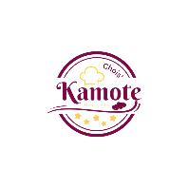



Crispy and delicious fries made from fresh Kamote, seasoned with a variety of spices and served with a selection of mouthwatering dipping sauces. Our Kamote Fries are a healthier alternative to traditional French fries, providing a satisfying and guilt-free snack or side dish option. Variations include:

* Kamote Fries Delight - Classic
* Kamote Fries Delight - Sweet and Salty
* Kamote Fries Delight – Caramelized
* Krunchy Kamote Fries Delight (Choco) - Limited Edition

18

**Kamote Doughnut Delights**





Soft and fluffy doughnuts made with the goodness of Kamote. These delightful treats come in a range of flavors and toppings, from classic sugar to unique combinations like salted caramel and toasted coconut. Our Kamote Doughnuts are perfect for breakfast indulgence or anytime enjoyment. Variations include:

* Kamote Doughnut Delight - Classic
* Kamote Doughnut Delight - Sugar Glazed
* Kreamy Kamote Doughnut Delight - Limited Edition

19

**Kamote Ice Candy Delights**



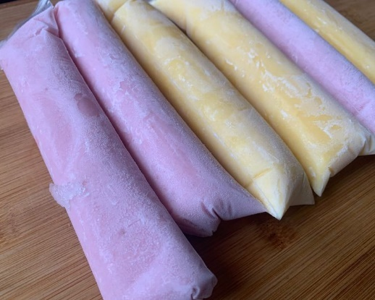

Refreshing frozen treats made from pureed Kamote and natural fruit flavors. Our Kamote Ice Candies offer a delightful burst of flavors and a cooling sensation, making them a popular choice for beating the heat. They are a healthier alternative to traditional ice cream, providing a guilt-free option for both kids and adults. Variations include:

* Kamote Ice Candy Delight – Ube
* Koolest Kombi Kamote Ice Candy Delight - Limited Edition

Our product and service offerings stand out in the market due to their innovative use of Kamote, commitment to quality ingredients, and dedication to exceptional taste. We prioritize sourcing fresh Kamote and other high-quality ingredients to ensure that every bite is filled with delightful flavors and textures. With Chois’ Kamote Delights, customers can enjoy a delectable range of Kamote-based treats that are not only satisfying to the taste buds but also offer the added benefits of nutrition and wholesomeness.

20

**VII. The Enterprise Strategy and Enterprise Delivery System: Business Competitiveness**

**Enterprise Strategy**

Chois’ Kamote Delights adopts a multi-faceted strategy to enhance its business competitiveness and meet the demands of the market. The key elements of our enterprise strategy include:

* Product Differentiation

We differentiate ourselves by offering a unique range of Kamote-based treats that are innovative, delicious, and nutritious. By incorporating Kamote into familiar favorites like fries, doughnuts, and ice candies, we provide customers with a distinct culinary experience not found elsewhere.

* Quality and Consistency

We place a strong emphasis on delivering consistent product quality, taste, and presentation. Through meticulous recipe development, rigorous quality control processes, and the use of fresh, high-quality ingredients, we ensure that every Kamote Delights product meets and exceeds customer expectations.

* Customer-Centric Approach

We prioritize customer satisfaction and seek to create exceptional experiences for every customer interaction. Our friendly and knowledgeable staff provide excellent service, and we actively seek and respond to customer feedback to continually improve our offerings and exceed customer expectations.

* Branding and Marketing

We invest in strategic branding and marketing efforts to build brand awareness, establish a strong brand identity, and reach our target market effectively. We utilize various channels such as social media, collaborations, and partnerships to engage with customers and promote our unique Kamote-based treats.

21

**Enterprise Delivery System**

Chois’ Kamote Delights employs an efficient and customer-centric delivery system to ensure a seamless and enjoyable experience for our customers. Our key focus areas in the enterprise delivery system include:

* Physical Locations

We establish physical outlets strategically located in high-traffic areas, ensuring convenience and accessibility for customers. Our physical locations are designed to create a welcoming and inviting atmosphere, providing a comfortable space for customers to enjoy their Kamote Delights.

* Online Ordering and Delivery

We offer a user-friendly online ordering system through our social media platform, allowing customers to conveniently place their orders for pickup or delivery. We partner with reliable delivery service providers to ensure timely and efficient delivery of our Kamote-based treats to customers' doorsteps.

* Continuous Improvement

We consistently evaluate and refine our enterprise delivery system to optimize efficiency and customer satisfaction. By adopting technology, streamlining processes, and embracing customer feedback, we strive to continuously enhance our delivery system to meet evolving customer expectations.

Through our well-defined enterprise strategy and efficient enterprise delivery system, Chois’ Kamote Delights aims to establish a strong foothold in the market, differentiate ourselves from competitors, and provide customers with an exceptional and delightful experience that keeps them coming back for more of our innovative Kamote-based treats.

22

**VIII. The Financial Forecasts and Expected Returns, Risks, and Contingencies**

**Financial Forecasts and Expected Returns**

Based on comprehensive market research and analysis, Chois’ Kamote Delights has developed the following financial forecasts and expected returns:

* Revenue Projections

We anticipate steady revenue growth over the next three weeks, driven by increasing brand awareness, customer loyalty, and market demand for our unique Kamote-based treats. Our revenue projections are as follows:

- Week 1: P 170

- Week 2: P 210 + 40%

- Week 3: P 305 + 95%

* Cost Analysis

We have conducted a thorough cost analysis, including the costs of raw materials, packaging, marketing expenses, overhead costs, and personnel. Through effective cost management strategies, we aim to optimize expenses and maintain healthy profit margins.

* Profitability

With a competitive pricing strategy and cost-efficient operations, we expect to achieve a sustainable level of profitability within the first week of operation. We anticipate a net profit margin of 30% by Week 3.

23

**Risks and Contingencies**

While we are confident in the potential success of Chois’ Kamote Delights, we acknowledge the presence of certain risks that may impact our financial performance. These risks include:

* Market Competition

The food industry is highly competitive, and there is a possibility of new entrants or existing competitors offering similar Kamote-based products. To mitigate this risk, we will continually innovate our product offerings, maintain high product quality, and focus on building customer loyalty through exceptional experiences.

* Fluctuating Ingredient Costs

The costs of Kamote and other ingredients may fluctuate due to market conditions and external factors such as weather events and supply chain disruptions. We will monitor and manage ingredient costs through supplier relationships, contract negotiations, and efficient inventory management practices.

* Changing Consumer Preferences

Consumer preferences and trends can evolve rapidly, affecting demand for specific products. We will stay attuned to market shifts, conduct regular market research, and adapt our offerings to meet changing customer needs and preferences.

* Operational Challenges

Efficient operations are crucial for profitability. We recognize the importance of maintaining smooth production processes, managing inventory effectively, and ensuring timely delivery. We will invest in staff training, streamline operations, and implement robust quality control measures to address potential operational challenges.

24

**Contingency Plans**

To mitigate risks and address unforeseen circumstances, Chois’ Kamote Delights has developed contingency plans to ensure business continuity:

* Diversification of Product Line

We will continuously explore new product development opportunities and expand our menu offerings to maintain customer interest and adapt to changing market demands.

* Financial Reserves

We will establish financial reserves to mitigate any short-term financial challenges that may arise due to unexpected circumstances or market fluctuations.

* Customer Loyalty Programs

We will implement customer loyalty programs and incentives to foster long-term relationships with our customers, promoting repeat business and enhancing brand loyalty.

* Agile Marketing and Promotion

We will maintain flexibility in our marketing and promotion strategies to respond swiftly to market changes, emerging trends, and competitive challenges.

Through diligent financial planning, risk assessment, and the implementation of contingency plans, Chois’ Kamote Delights aims to optimize financial performance, mitigate risks, and ensure long-term sustainability and profitability in the dynamic food market.

25

**IX. Environmental and Regulatory Compliance**

**Environmental Responsibility**

Chois’ Kamote Delights is committed to operating in an environmentally responsible manner. We recognize the importance of sustainable practices to minimize our ecological footprint. Our environmental initiatives include:

* Waste Management

We will implement proper waste management systems to reduce waste generation, promote recycling, and ensure responsible disposal of waste materials.

* Energy Efficiency

We will strive to minimize energy consumption by utilizing energy-efficient equipment and implementing practices to optimize energy usage within our operations.

* Sustainable Packaging

We will source eco-friendly packaging materials whenever possible and explore options for biodegradable or recyclable packaging to minimize environmental impact.

* Local Sourcing

We will prioritize sourcing ingredients from local suppliers to support local farmers and reduce the carbon footprint associated with transportation.

26

**Regulatory Compliance**

Chois’ Kamote Delights is committed to full compliance with all applicable regulations and laws governing food preparation, hygiene, safety, and employment. We will ensure adherence to the following regulatory requirements:

* Food Safety Standards

We will comply with all local, regional, and national food safety regulations to maintain the highest standards of food hygiene and safety. This includes proper handling, storage, and preparation of ingredients to prevent contamination.

* Health and Safety

We will implement robust health and safety protocols to provide a safe working environment for our employees and customers. This includes regular equipment maintenance, training programs, and adherence to occupational health and safety regulations.

* Licensing and Permits

We will obtain all necessary licenses and permits required for food preparation, operation, and sales. This includes health permits, business licenses, and any other permits specific to our location.

* Employment Laws

We will comply with labor laws and regulations, ensuring fair employment practices, proper wages, and compliance with labor standards.

We will regularly monitor changes in environmental and regulatory requirements to ensure ongoing compliance and make necessary adjustments to our operations. By upholding environmental responsibility and regulatory compliance, Chois’ Kamote Delights aims to build trust with customers, employees, and the community while contributing to a sustainable and responsible business ecosystem.

27

**X. The Capital Structure and Financial Offering: Returns and Benefits to Investors, Financiers, and Business Partners**

Chois’ Kamote Delights presents an attractive capital structure and financial offering that provides substantial returns and benefits to investors, financiers, and business partners. Our comprehensive financial plan is designed to ensure profitability and sustainable growth. Here are the key aspects of our capital structure and financial offering:

* **Investment Opportunities**

- We welcome potential investors to participate in Kamote Delights and become part of our exciting journey. By investing in our business, investors can benefit from the growth potential of a dynamic and innovative food venture.

- Our investment opportunities offer attractive returns through capital appreciation and profit-sharing mechanisms. We have structured our financial offering to provide competitive and lucrative rewards for investors.

* **Strong Profit Potential**

- Chois’ Kamote Delights has a well-defined revenue model and cost management strategies to maximize profitability. With our unique and appealing Kamote-based product offerings, we anticipate strong demand and consistent sales growth.

- Our comprehensive financial projections demonstrate a clear path to achieving profitability within a reasonable timeframe. By executing our business plan effectively, we aim to generate robust returns on investment.

* **Investor Support and Transparency**

- We prioritize investor satisfaction and provide regular updates on the business performance and financial results. Our transparent reporting and open communication channels enable investors to stay informed and engaged throughout their investment journey.

- Additionally, we have implemented robust corporate governance practices to ensure accountability and safeguard the interests of our investors and stakeholders.

28

* **Collaborative Partnerships**

- We actively seek strategic partnerships with financiers, suppliers, and business partners who share our vision and can contribute to our growth. These partnerships offer mutual benefits, such as access to new markets, enhanced operational capabilities, and shared resources.

- Through collaborations, we can leverage the expertise and network of our partners to optimize our operations and expand our market reach, creating a win-win situation for all involved parties.

* **Potential for Business Expansion**

- With the increasing popularity of Kamote-based products and the growing demand for healthy and innovative food options, Chois’ Kamote Delights has significant potential for business expansion.

- As we achieve profitability and establish a strong brand presence, we plan to explore franchise opportunities, open new outlets in strategic locations, and expand our product lines. This expansion will offer additional growth prospects and enhanced returns for investors and business partners.

In summary, Cois’ Kamote Delights presents an enticing capital structure and financial offering that offers attractive returns and benefits to investors, financiers, and business partners. With our strong profit potential, investor support and transparency, collaborative partnerships, and the potential for business expansion, we invite interested parties to join us in shaping the future of Chois’ Kamote Delights and capitalize on the exciting opportunities in the food industry.

29

**Appendix**

**Market Research Findings**

1. Customer Demographics

* Age: Our primary target market falls with all ages.
* Gender: Our products appeal to both males and females.
* Location: We primarily focus on urban and suburban areas with a significant population density.
* Socioeconomic Status: Our products cater to a diverse range of customers across different socioeconomic backgrounds.

2. Customer Preferences

* Taste Preferences: Our market research indicates that customers enjoy a variety of flavors, ranging from classic to unique and innovative combinations.
* Dietary Preferences: We cater to customers with different dietary preferences, including vegetarian and vegan options.
* Health Consciousness: There is a growing demand for healthier alternatives, and our Kamote-based products meet this need by providing nutritious and wholesome options.
* Convenience: Customers value convenience and are drawn to products that are easy to consume on-the-go or as a quick snack.

3. Customer Behavior

* Purchase Frequency: Our research shows that customers purchase Kamote-based products regularly, often as a snack or dessert.
* Occasions: Our products are popular for various occasions, including casual outings, social gatherings, and special events.
* Social Media Influence: Customers heavily rely on social media platforms to discover new food trends, share experiences, and make purchasing decisions.
* Brand Loyalty: Building brand loyalty is crucial, and customers appreciate consistent quality, excellent customer service, and engaging brand experiences.

4. Market Size and Growth

* The Kamote-based food market is experiencing steady growth due to increasing consumer awareness of healthier food options.
* There is a growing demand for unique and innovative snacks, providing an opportunity for Chois’ Kamote Delights to capture market share.
* Market size is influenced by factors such as population density, urbanization, and changing consumer preferences.

5. Competitive Landscape

* + Our market research identifies several competitors offering Kamote-based products, ranging from local food stalls to established dessert chains.
  + To differentiate ourselves, we focus on product quality, diverse flavor options, creative presentations, and a strong brand identity.
  + Continuous market analysis is essential to stay updated on competitors' offerings, pricing strategies, and customer feedback.

By analyzing customer demographics, preferences, and behavior, we have gained valuable insights to shape our product offerings, marketing strategies, and customer engagement. This market research data provides a solid foundation for our business decisions and enables us to meet the evolving needs of our target customers effectively.

30

**Organizational Structure**

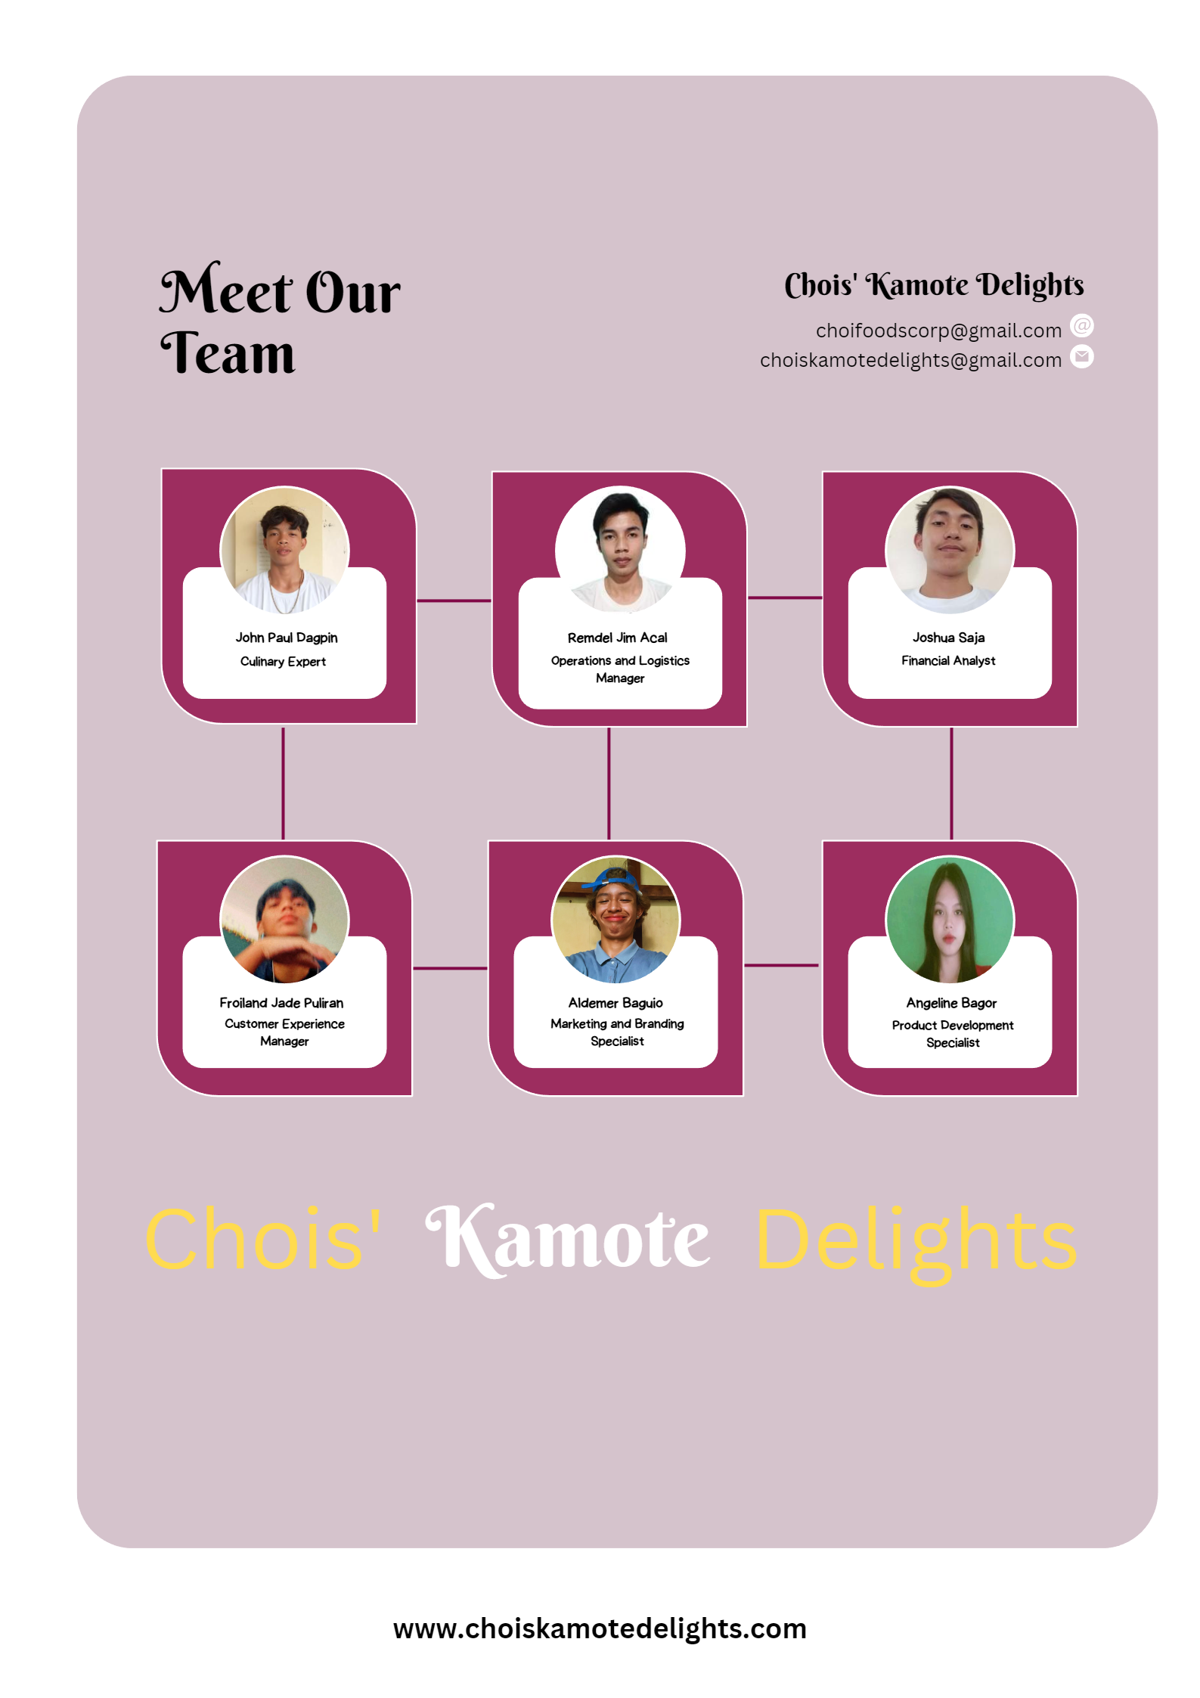

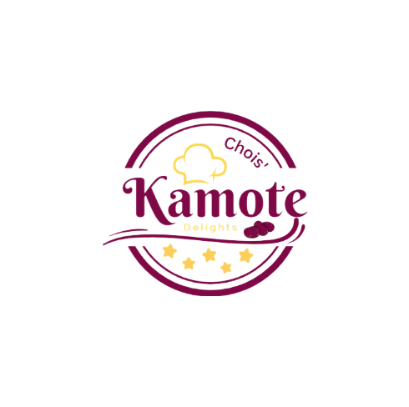

31

**Marketing and Advertising Collaterals**

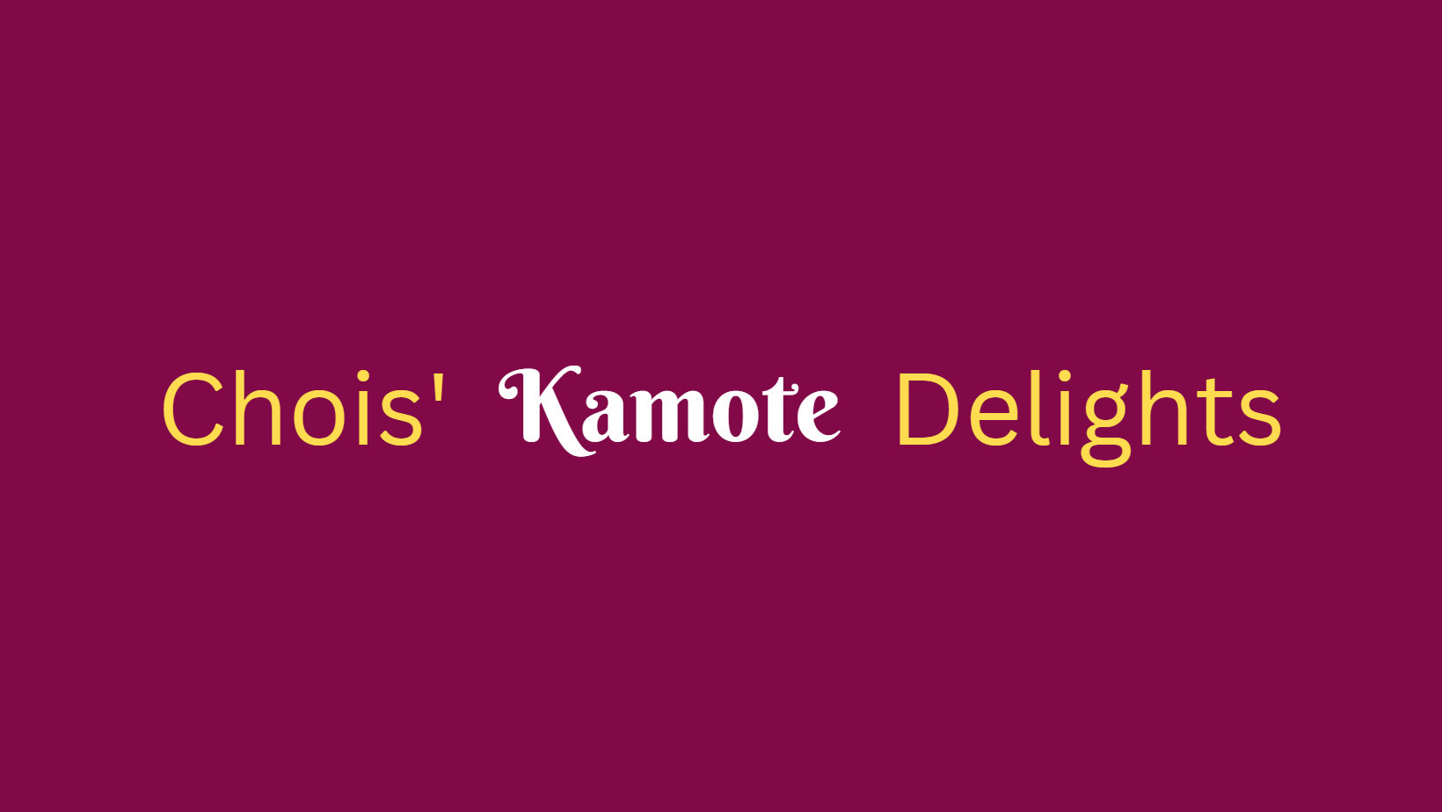

32

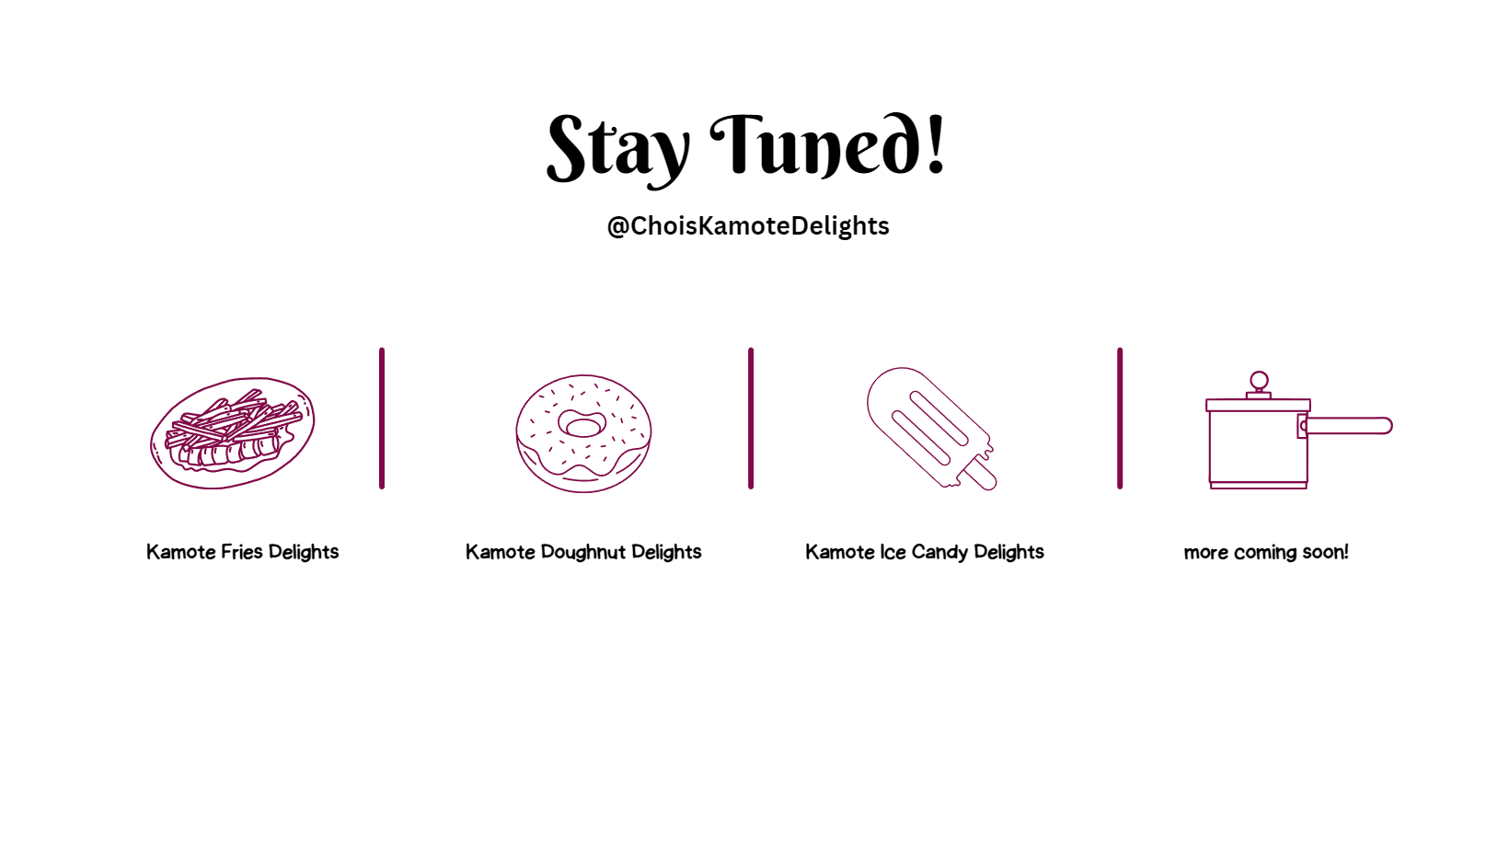

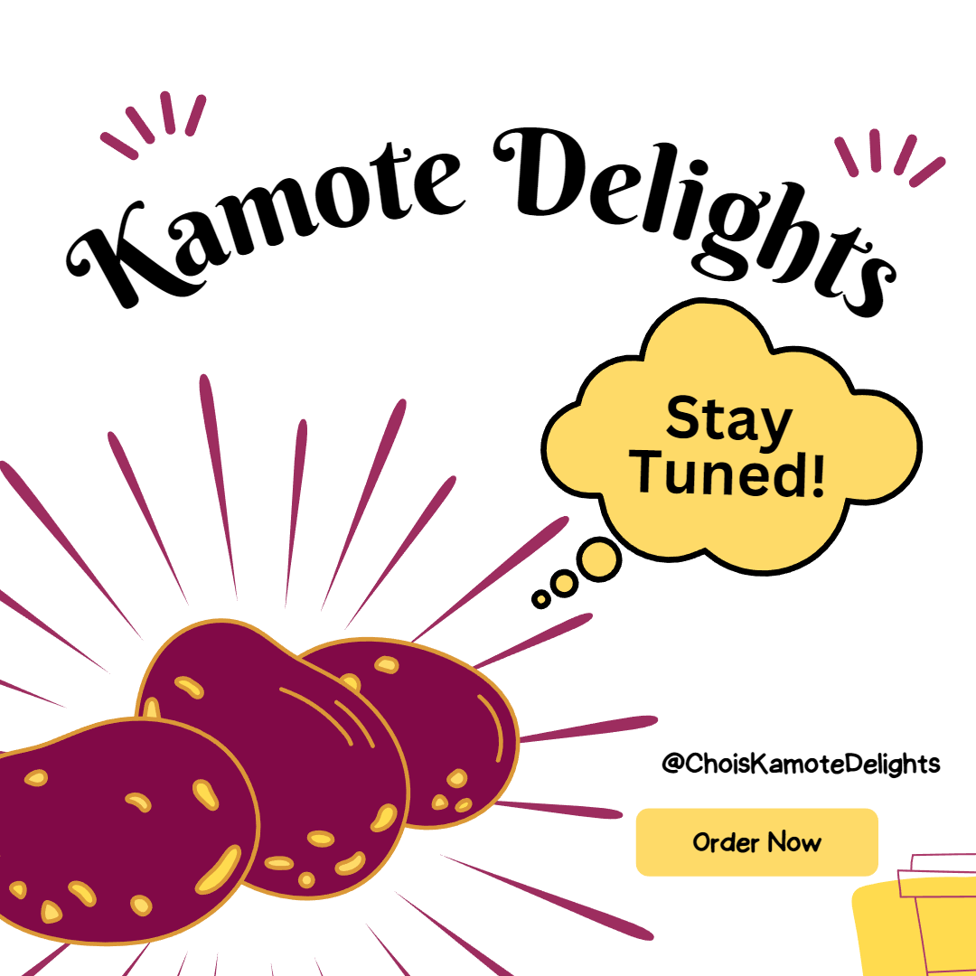

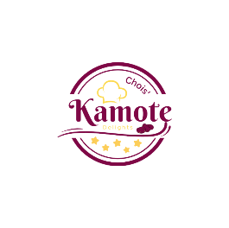

33

**Environmental Sustainability Initiatives**

- Description of environmental sustainability practices implemented by Kamote Delights.

- Efforts to reduce waste, conserve resources, and minimize the carbon footprint.

- Collaboration with suppliers and partners committed to sustainability.

**Supporting Documents**

- Any additional supporting documents, such as testimonials, letters of intent, or partnerships agreements.

